IT 5434 Network Security Fundamentals
Lab Assignment 6 (L6)
60 points
Due: see due date under Dropbox on Folio

Student Name: Emmanuel Opara
Eagle ID: 901305850
Module 04 Authorization (RWX and ACL)
- Linux RWX permissions. Complete the following tasks in Linux. (25 points)
  - Create a new file with its file name using your first name_last name (e.g., “Lei_Chen”) using command “touch”. Use “ls” command with appropriate option(s) to show the current file permissions of the file and paste screenshot below. Explain the details of the file permissions. (4 points)
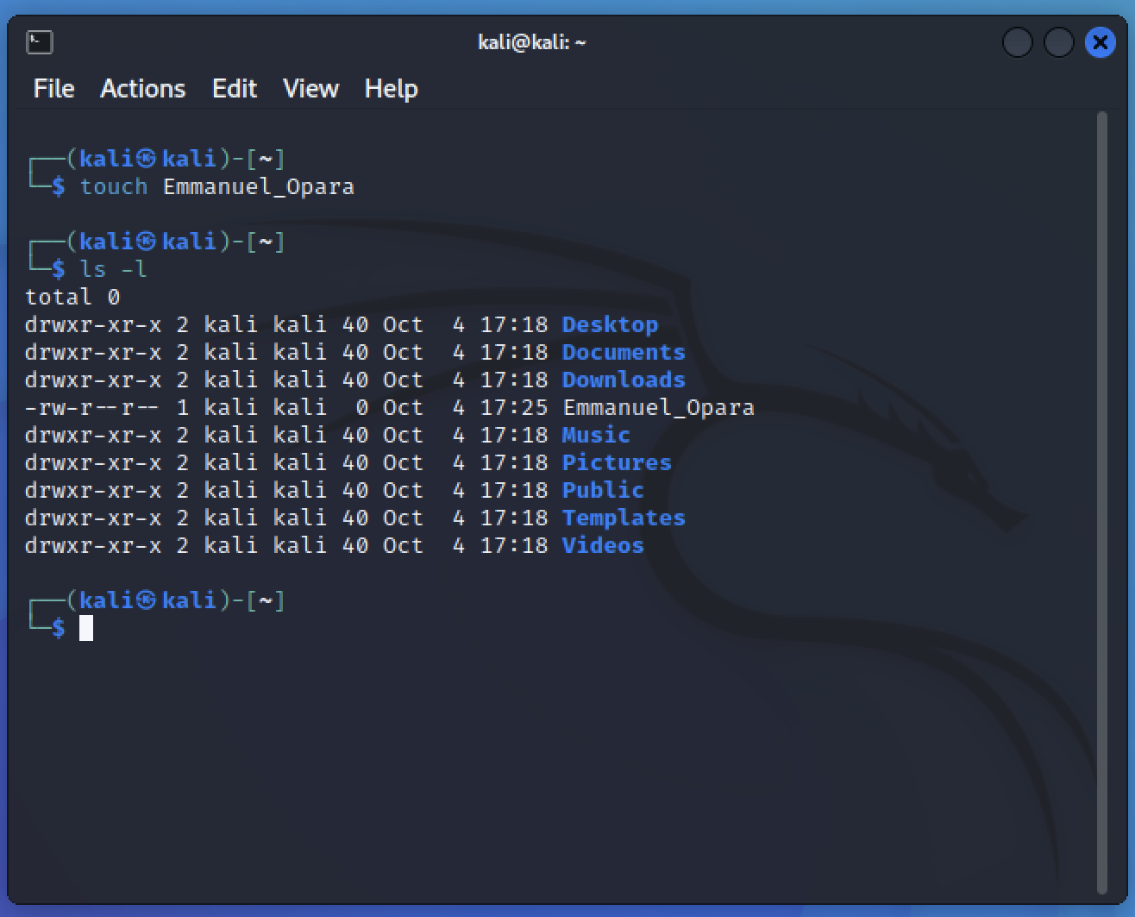

  - Use “chmod” command (use sudo in front of chmod if needed) to configure the file’s permissions and give ALL permissions to owner, read and execute permissions to owner’s group, and read only permissions to others. Use “ls” command with appropriate option(s) to show the current file permissions and paste screenshot. (4 points)

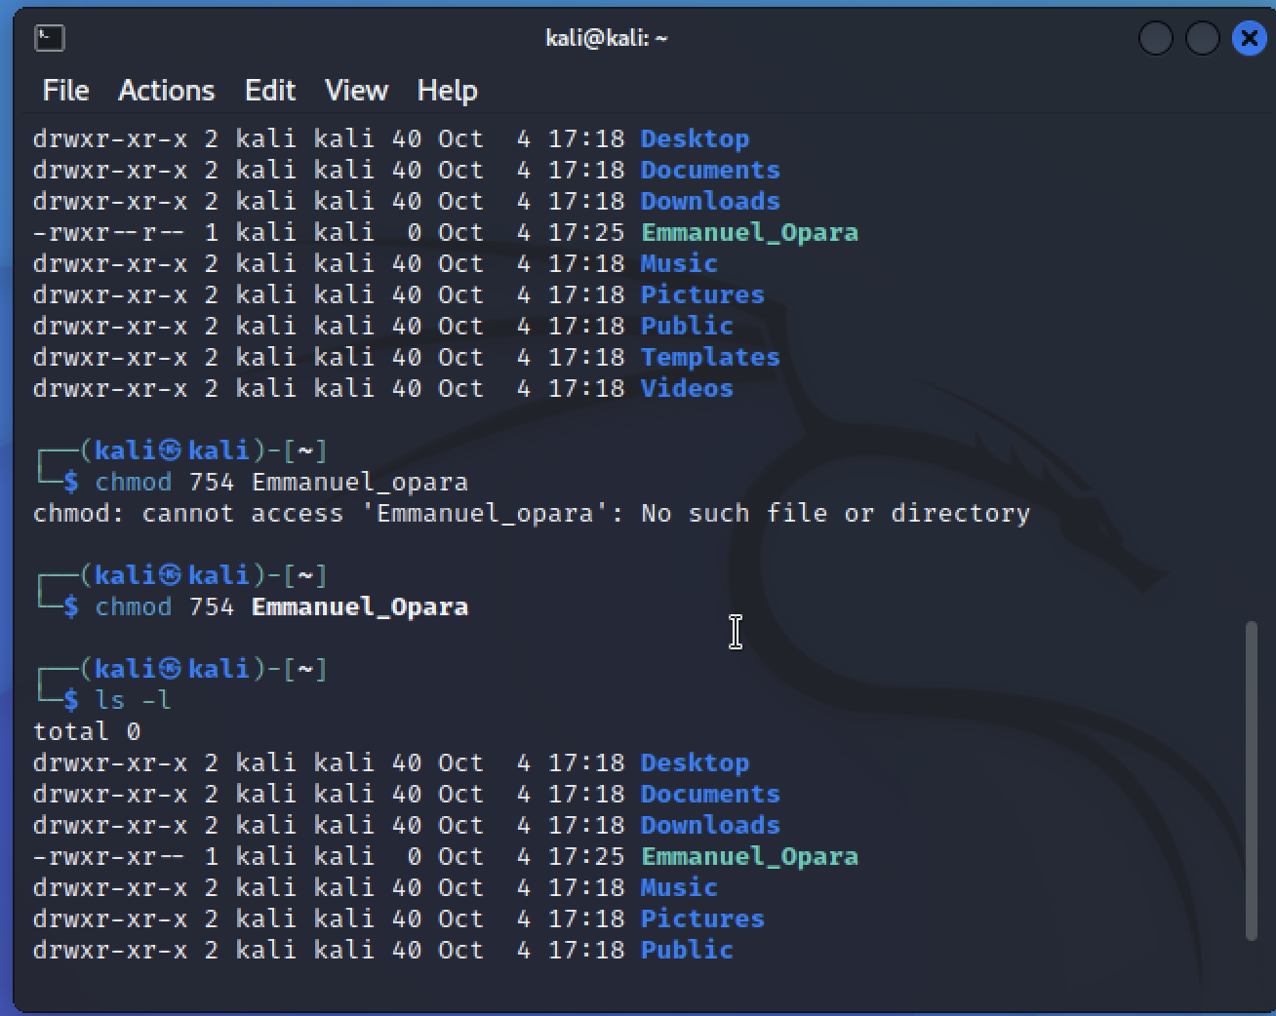

  - Use “chmod” command with numbers to give the file the read and write permissions to owner, and no permissions to anyone else. Use “ls” with appropriate option(s) to show the current file permissions and paste screenshot. (4 points)
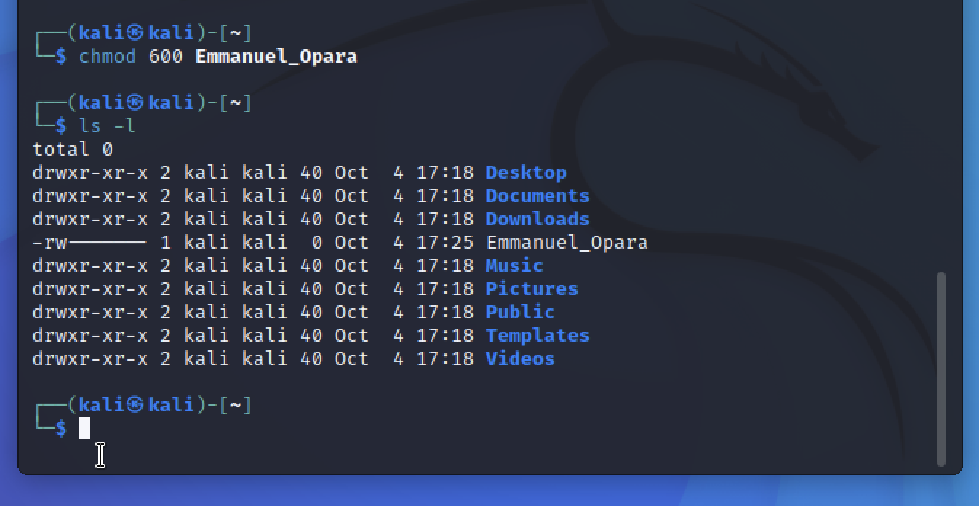

  - Use “chmod” command, with “-“ option and rwx letter(s), to remove the write permission of the file from owner. Use “ls” with appropriate option(s) to show the current file permissions and paste screenshot. (4 points)
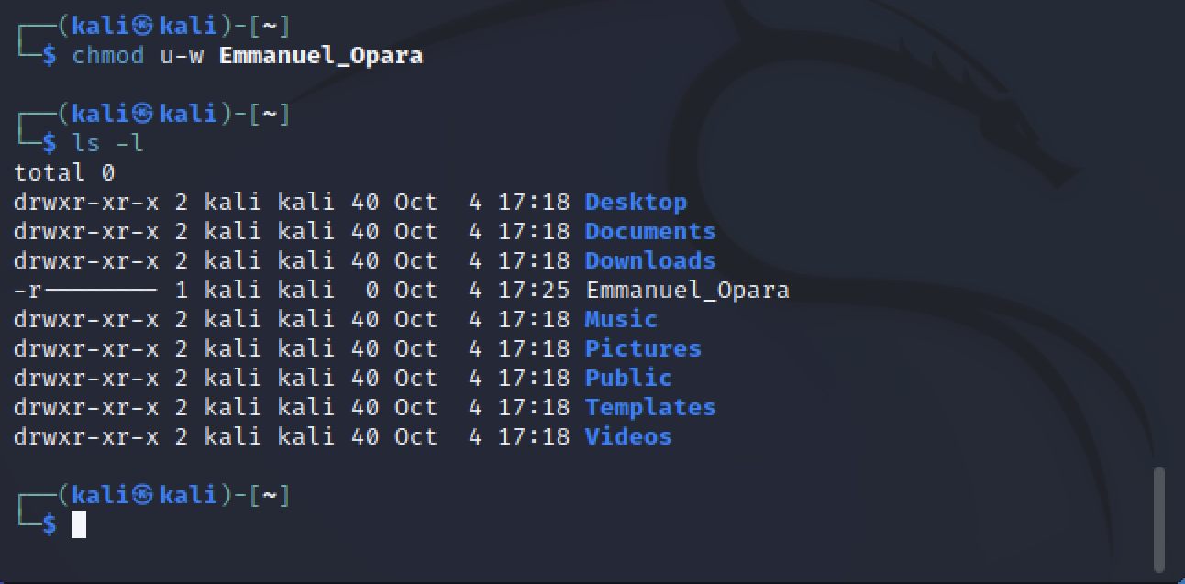

  - What does the command sudo chmod 755 followed by your file name do? What would be a typical scenario for setting such file permissions? (4 points)
The sudo chmod 755 command assigns the read, write, and execute permission to the owner, while it assigns the read and execute permission to the group and others.

The best scenario to activate this permission is when multiple users demand access to this file or directory. It is usually assigned to users who all the same security access clearance to a file or directory in an organization.

  - Create a directory d1 (using command “mkdir”) and set it with 755 permissions, then inside d1 create a file f1 and a directory d2, both with 755 permissions. Show screenshots. Would command “sudo chmod 644 d1” (the parent directory) set the permissions 644 to both f1 and d2 (the children file and directory)? If not, what is the command to recursively set permission 644 to all subdirectories and files under d1 (hint: see the manual page of chmod command or search online)? (5 points)

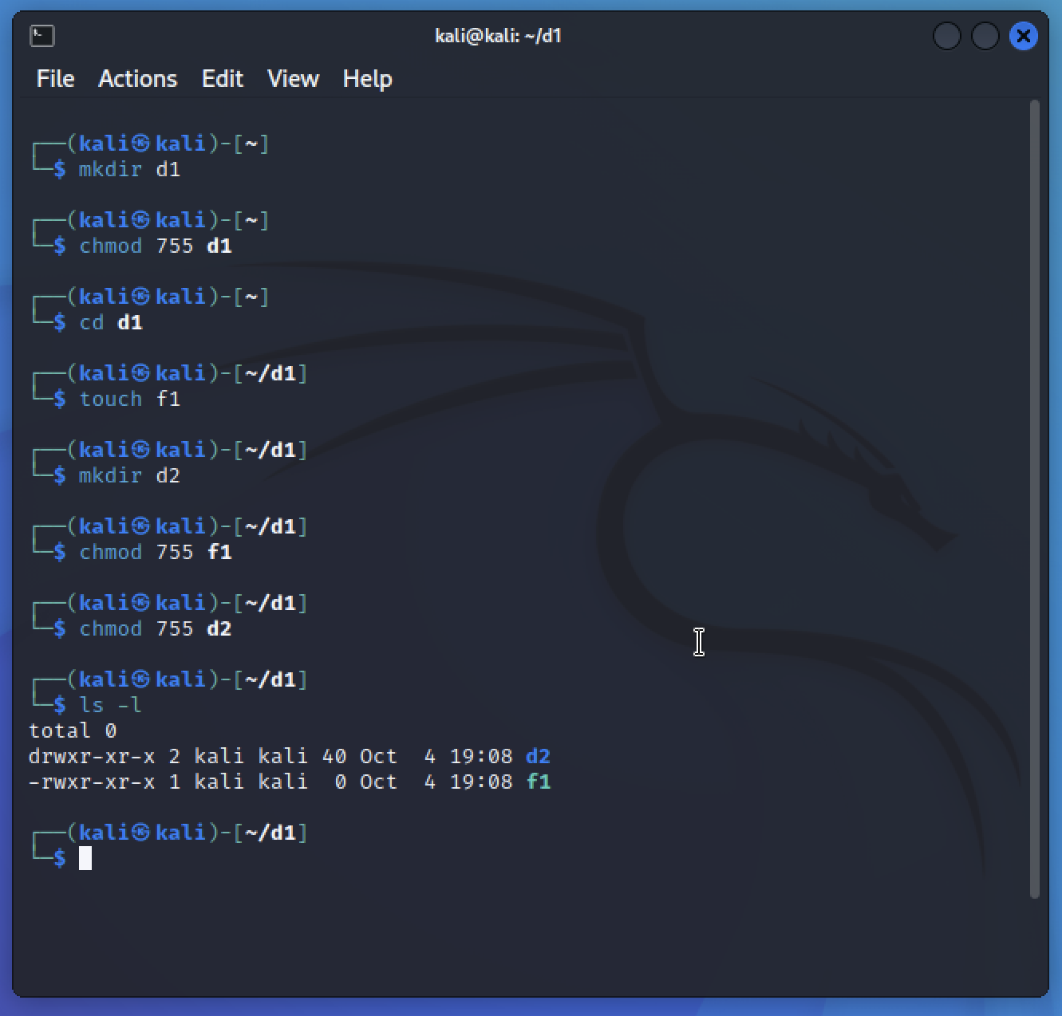

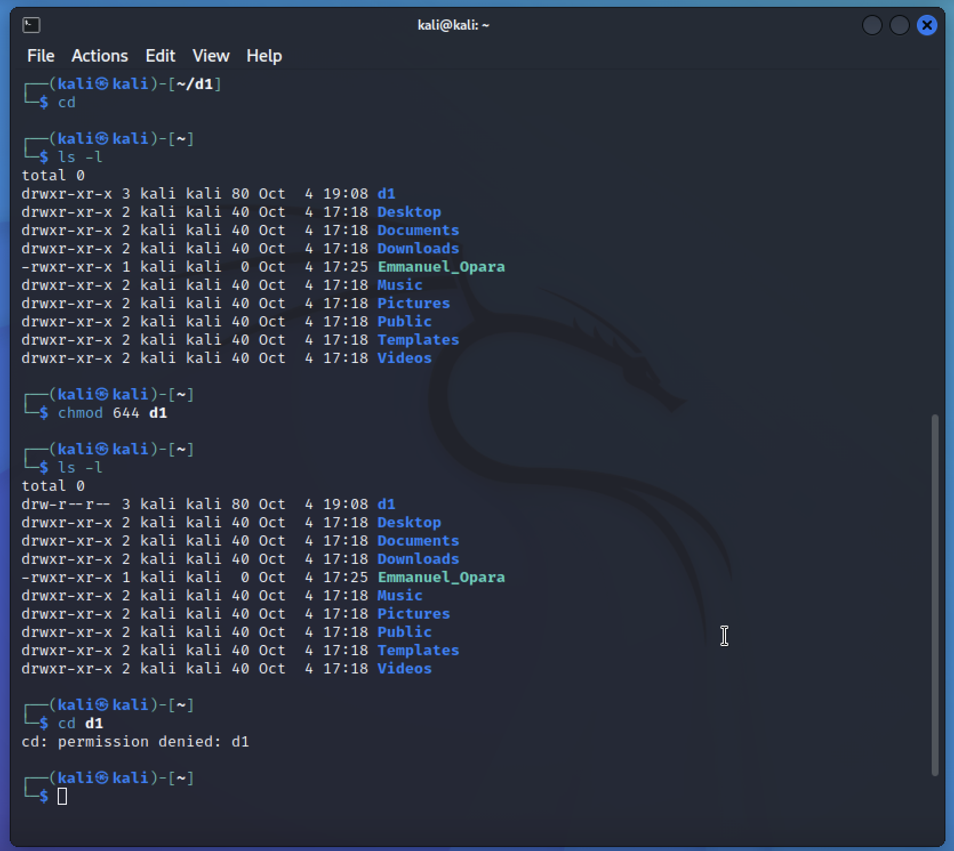

- Linux ACL. Suppose you, Alex, and Billy are working on a project where you want to have shared file(s) and folder with specific permissions using ACLs. Since you are the team leader, you want to have the full access to all files and folders and oversee creating them and configuring the corresponding permissions and ACLs. Complete the following tasks and show screenshots (must show the commands entered and the results returned for each step). Where necessary, use command “man” followed by the actual command to see command manual pages. (35 points)
  - Create a group with group name “mygroup” using the “groupadd” command. (2 points)

  - Create user Alex under mygroup using command “useradd” with “-G” option. Then create user Billy under the same group. (5 points)

  - Create a folder with name “myproject”. Show the current ACL of myproject. (5 points)

  - Use “setfacl -m” command to add an ACL rule for myproject so that you have full access, Alex and Billy have read and write access, and mygroup also has read and write access. Show the current ACL of myproject. (6 points)

  - Create a file with name “f1”, within myproject folder, using the “touch” command. Show the ACL of f1. (5 points)

  - Use “setfacl –m” command to give Alex read and write access to f1, only read access for Billy to f1, and only read access for mygroup to f1. Show the ACL of f1. (6 points)

  - Use “setfacl –m” to set an ACL mask with read access to f1. Then show ACL of f1 and specify whose access to f1 has been affected and how it is affected. (6 points)

